**UD1. Algoritmos de planificación.**

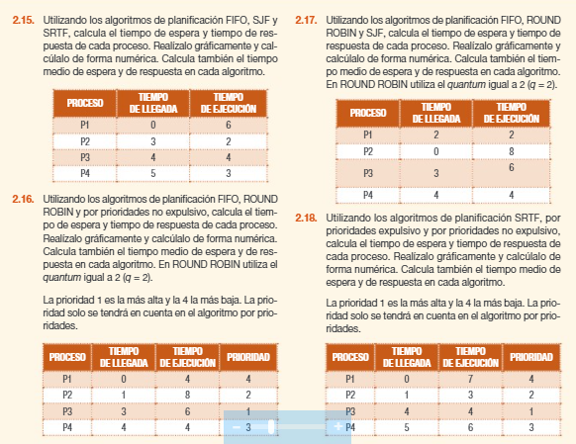

2.15

FIFO

|  |  |  |  |  |
| --- | --- | --- | --- | --- |
| PROCESO | TL | TX | TR | TE |
| **P1** | **0** | **6** | 6 | 0 |
| **P2** | **3** | **2** | 5 | 3 |
| **P3** | **4** | **4** | 8 | 4 |
| **P4** | **5** | **3** | 10 | 7 |
|  |  | MEDIA »» | 7,25 | 3,5 |

SJF

|  |  |  |  |  |
| --- | --- | --- | --- | --- |
| PROCESO | TL | TX | TR | TE |
| **P1** | **0** | **6** | 6 | 0 |
| **P2** | **3** | **2** | 5 | 3 |
| **P3** | **4** | **4** | 11 | 7 |
| **P4** | **5** | **3** | 6 | 3 |
|  |  | MEDIA »» | 7 | 3,25 |

SRT

|  |  |  |  |  |
| --- | --- | --- | --- | --- |
| PROCESO | TL | TX | TR | TE |
| **P1** | **0** | **6** | 8 | 2 |
| **P2** | **3** | **2** | 2 | 0 |
| **P3** | **4** | **4** | 11 | 6 |
| **P4** | **5** | **3** | 6 | 3 |
|  |  | MEDIA »» | 6,75 | 2,75 |

2.16

FIFO

|  |  |  |  |  |
| --- | --- | --- | --- | --- |
| PROCESO | TL | TX | TR | TE |
| **P1** | **0** | **4** | 4 | 0 |
| **P2** | **1** | **8** | 11 | 3 |
| **P3** | **3** | **6** | 15 | 9 |
| **P4** | **4** | **4** | 18 | 14 |
|  |  | MEDIA »» | 12 | 6,5 |

RR q=2

|  |  |  |  |  |
| --- | --- | --- | --- | --- |
| PROCESO | TL | TX | TR | TE |
| **P1** | **0** | **4** | 6 | 2 |
| **P2** | **1** | **8** | 21 | 13 |
| **P3** | **3** | **6** | 17 | 11 |
| **P4** | **4** | **4** | 14 | 10 |
|  |  | MEDIA »» | 14,5 | 9 |

Prioridad no expulsivo

|  |  |  |  |  |  |
| --- | --- | --- | --- | --- | --- |
| PROCESO | TL | TX | PRIORIDAD | TR | TE |
| **P1** | **0** | **4** | **4** | 4 | 0 |
| **P2** | **1** | **8** | **2** | 17 | 9 |
| **P3** | **3** | **6** | **1** | 7 | 1 |
| **P4** | **4** | **4** | **3** | 18 | 14 |
|  |  |  | MEDIA »» | 11,5 | 6 |

2.17

FIFO

|  |  |  |  |  |
| --- | --- | --- | --- | --- |
| PROCESO | TL | TX | TR | TE |
| **P1** | **2** | **2** | 8 | 6 |
| **P2** | **0** | **8** | 8 | 0 |
| **P3** | **3** | **6** | 13 | 7 |
| **P4** | **4** | **4** | 16 | 12 |
|  |  | MEDIA »» | 11,25 | 6,25 |

RR q=2

|  |  |  |  |  |
| --- | --- | --- | --- | --- |
| PROCESO | TL | TX | TR | TE |
| **P1** | **2** | **2** | 2 | 0 |
| **P2** | **0** | **8** | 18 | 10 |
| **P3** | **3** | **6** | 17 | 11 |
| **P4** | **4** | **4** | 12 | 8 |
|  |  | MEDIA »» | 12,25 | 7,25 |

SJF

|  |  |  |  |  |
| --- | --- | --- | --- | --- |
| PROCESO | TL | TX | TR | TE |
| **P1** | **2** | **2** | 8 | 6 |
| **P2** | **0** | **8** | 8 | 0 |
| **P3** | **3** | **6** | 17 | 11 |
| **P4** | **4** | **4** | 10 | 6 |
|  |  | MEDIA »» | 10,75 | 5,75 |

2,18

SRFT

|  |  |  |  |  |
| --- | --- | --- | --- | --- |
| PROCESO | TL | TX | TR | TE |
| **P1** | **0** | **7** | 14 | 7 |
| **P2** | **1** | **3** | 3 | 0 |
| **P3** | **4** | **4** | 4 | 0 |
| **P4** | **5** | **6** | 15 | 9 |
|  |  | MEDIA »» | 9 | 4 |

Prioridad expulsivo

|  |  |  |  |  |  |
| --- | --- | --- | --- | --- | --- |
| PROCESO | TL | TX | PRIORIDAD | TR | TE |
| **P1** | **0** | **7** | **4** | 20 | 13 |
| **P2** | **1** | **3** | **2** | 3 | 0 |
| **P3** | **4** | **4** | **1** | 4 | 0 |
| **P4** | **5** | **6** | **3** | 9 | 3 |
|  |  |  | MEDIA »» | 9 | 4 |

Prioridad no expulsivo

|  |  |  |  |  |  |
| --- | --- | --- | --- | --- | --- |
| PROCESO | TL | TX | PRIORIDAD | TR | TE |
| **P1** | **0** | **7** | **4** | 7 | 0 |
| **P2** | **1** | **3** | **2** | 13 | 10 |
| **P3** | **4** | **4** | **1** | 7 | 3 |
| **P4** | **5** | **6** | **3** | 15 | 9 |
|  |  |  | MEDIA »» | 10,5 | 5,5 |